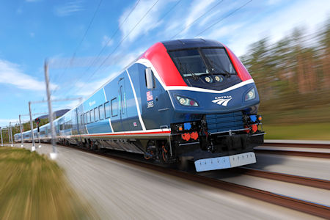
Amtrak Airo (Picture Curtesy of Amtrak)
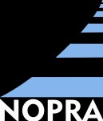 | Northwest Ohio Passenger Rail Association  Toledo Rail Forum
“ Beyond Amtrak as a sole‐source provider; how
Ohio can create a public/private regional partnership
for development and operation of passenger trains.”
 |  | Monday, February 27, 2023
 |  | 11:00 a.m. – 1:30 p.m.
The Grand Lobby (3rd Floor) Toledo Rail Station
300 Martin Luther King, Jr. Dr., Toledo, Ohio
Featured Speaker - Jim Coston
Executive Chairman Corridor Rail Development

Amtrak Update – Derrick James
Amtrak Director, Government Affairs
$50 non-members, $40 NOPRA and TMACOG members, $25 Students
Luncheon buffet included
Online registration (preferred): https://www.eventbrite.com/e/toledo-rail-forum-tickets-517910282597?aff=ebdssbdestsearch
Or you may register by returning this form:
Name |  |  |  | Title
Organization
Address
City |  |  | State |  | ZIP
E-mail |  |  |  |  | Phone
Will attend: $50 non-member  $40 NOPRA or TMACOG member  $25 student |  | Cannot attend, but wish to receive more information
Check enclosed (payable to NOPRA)  Please invoice, attention: _ ________________________________ |  | Will pay at the door (check or cash, please)  Late cancellations, 3 business days in advance or less, may be invoiced
Return: | Northwest Ohio Passenger Rail Association (NOPRA)  PO Box 839, Toledo OH 43697  419-824-5462 NWOhioPassengerRail@gmail.com

